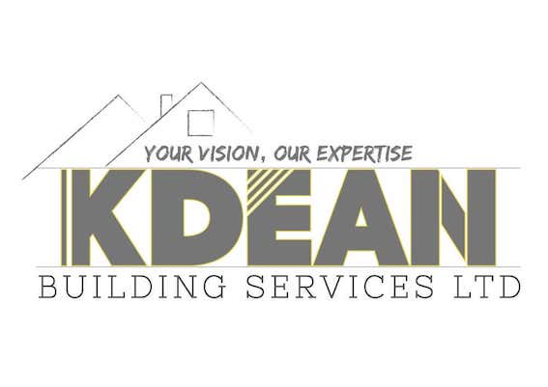
K Dean Building Services Ltd - ENVIRONMENTAL POLICY STATEMENT
K Dean Building Services Ltd has a policy to comply with the current Environmental Protection Act, other associated statutory legislation and Approved Codes of Practice (ACOP). This applies to all those who are employed within the company or who are protected by its undertakings. This policy is available to interested parties on request.
It is our policy to do all that is reasonably practicable to:
- reduce the level of energy consumption and obtain utility and hardware supplies from environmentally friendly organisations and those who use renewable energy sources
- recycle equipment, waste products, redundant items and reduce the consumption of consumables
- use, store, control and dispose of hazardous materials in line with best environmental practices.
In particular, it is our policy to:
Obtain services, equipment and power from providers who are committed to environmental protection.
Aim to reduce pollution and actively pursue reduction in the use of substances, processes and procedures that adversely affect the environment.
Consult with workers through the Safety Committee on any matter that may affect them related to environmental control.
Continually improve the firm’s environmental performance by setting annual targets and reviewing our objectives and measure the progress.
Carry out an annual review and update of this policy and other environmental control systems employed by the firm.
Workers are asked to co-operate in the operation of this policy and make a positive contribution to environmental protection by making themselves aware of the firm’s environmental policy and complying with the control measures in place.

Name: Kole Dean

Position: Director

Date: 11/01/2021

Signed…………………………………………………………………………………….

